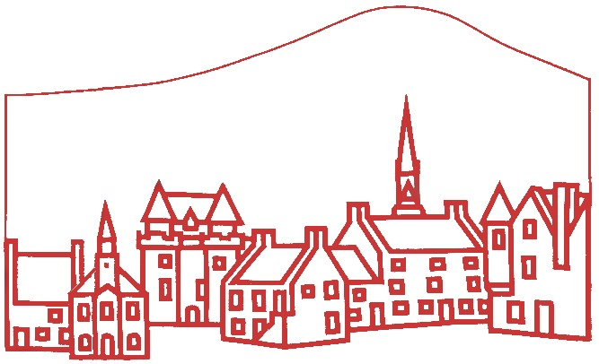
The Falkland Society
www.falklandsociety.org.uk www.historicfalkland.scot www.falkland.wiki
Membership Form, 2026
To: The Treasurer, Falkland Society, Bank House, High Street, Falkland, Fife KY15 7BZ
or by email to: membership@falklandsociety.org.uk
Please enrol me as a member of The Falkland Society for 2026.
The Falkland Society exists to promote knowledge and understanding of the archaeological, architectural, historic, environmental and artistic heritage, past and present, of Falkland and its wider context in Fife and Scotland. Members are entitled to receive copies of Society mailings and to vote in the Annual General Meeting, and most importantly your subscription will be helping the work of the Society.
Name: | Please reclaim Gift Aid* on my subscription / donation so that each £1 is worth an extra 25p to The Falkland Society.
Email:
Amount paid: annual subscription: (£10 per person): Additional voluntary donation:
£
£
Name: (second person at same address) | Please reclaim Gift Aid* on my subscription / donation so that each £1 is worth an extra 25p to The Falkland Society
Email:
Amount paid: annual subscription: (£10 per person): Additional voluntary donation:
£
£
Address (including postcode):
I can help in practical ways as follows:

I have made an online payment to the “Falkland Society” account with the Bank of Scotland,
sort code 80–06–26, account number 00325713, giving my surname as the reference.
I have asked my bank to make this a standing order / repeat payment.
OR: I have paid by PayPal using the form on the ‘Contact’ page: falklandsociety.org.uk/contact.shtml
OR: I enclose my annual subscription / donation as below:
£
cash cheque (payable to “Falkland Society”) Total paid:
Signature: |  | Date:

* Gift Aid: I am a UK taxpayer and understand that if I pay less Income Tax and/or Capital Gains Tax in the current tax year than the amount of Gift Aid claimed on all my donations it is my responsibility to pay any difference.
I consent to The Falkland Society storing the personal information above while I am a member of the Society and for up to 12 months thereafter, to supply me with information, contact me about events, and remind me to renew my membership. I can revoke this consent at any time by informing the Secretary. The Society will not share any information about me with third parties.
07/07/2026 W

